Part 2

A)

Write a multithreaded sorting program that works as follows: A list of integers is divided into Four smaller lists of equal size.

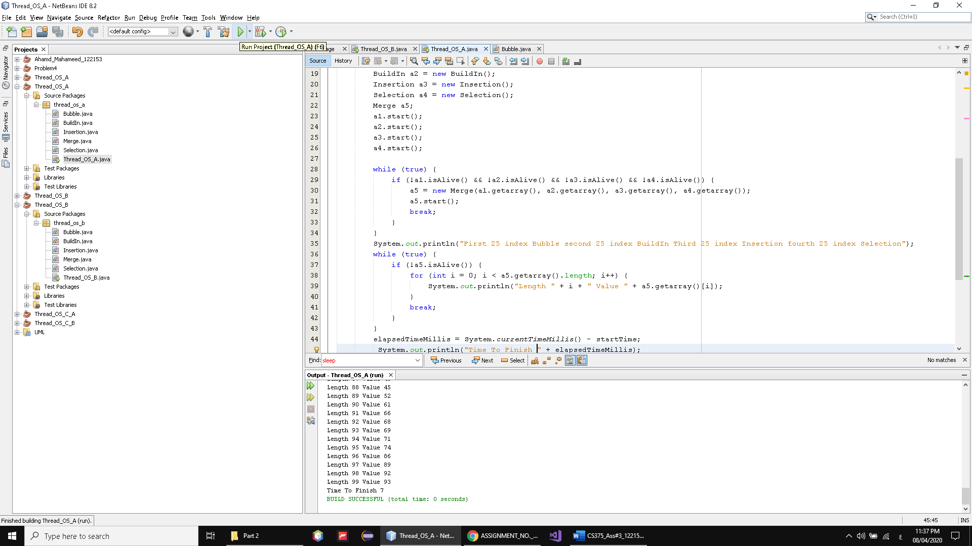

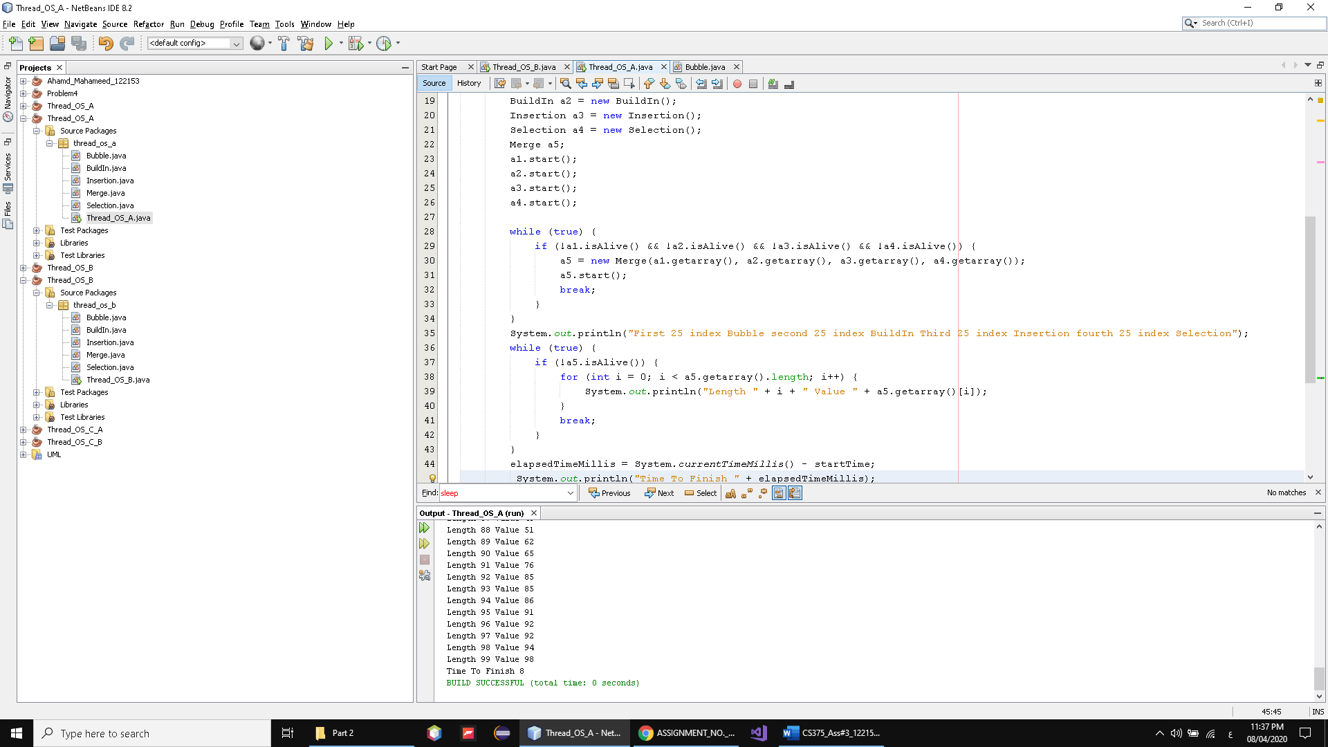

4 classes 4 algo sorted each part of array and I don’t know why don’t use reference and the 5 thread 5 class merge them

Time from 7 – 8 special 6

B)

A)Solve the previous problem without using threads. Use the time function with each part (a and b) and show, for each one, what is the exact execution time? Is there any difference? Why? You have to answer these questions in your report.

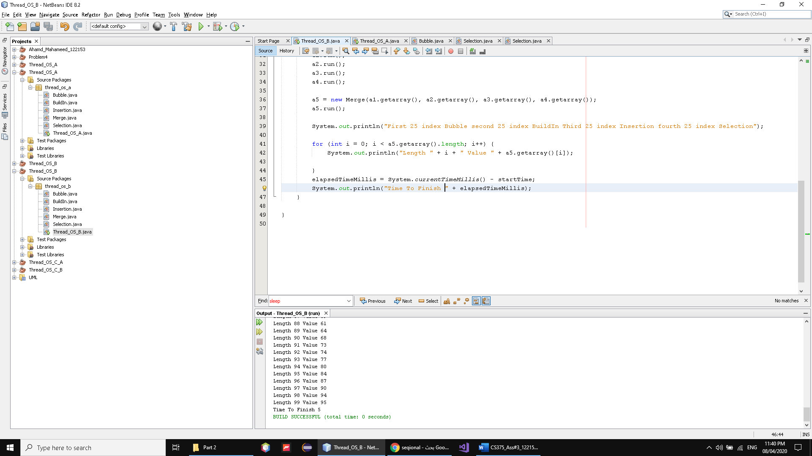

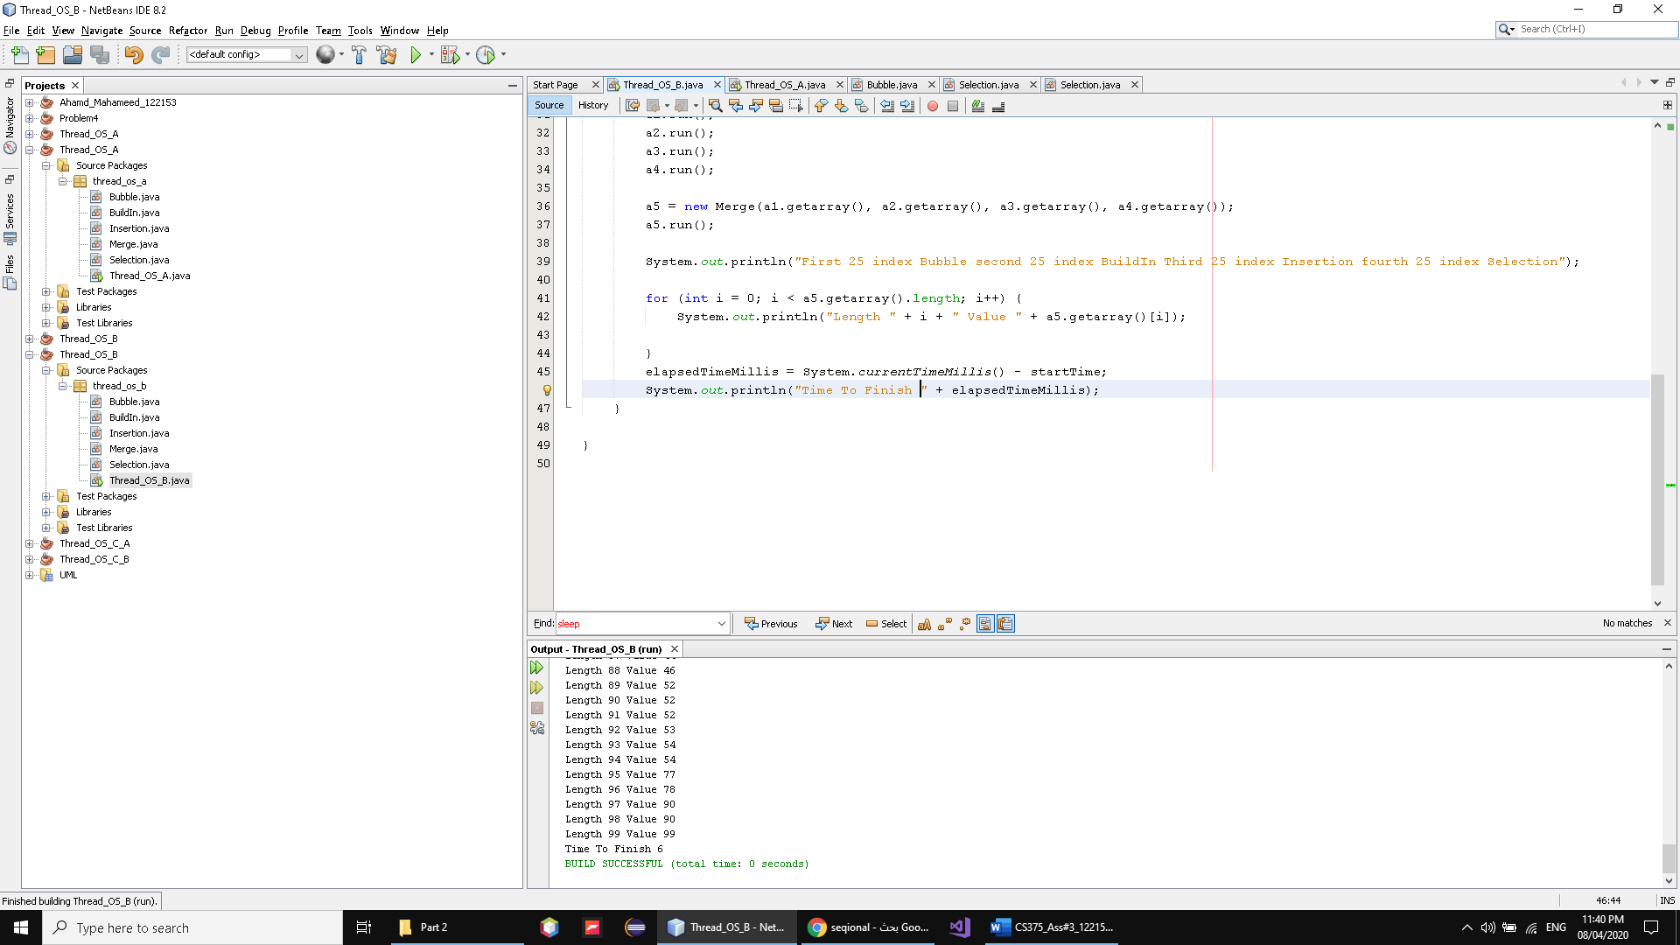

what is the exact execution time?

As we see from 5 to 6 single

As we see from 6 to 7 Thread

Is there any difference?

yes

Why?

Because before use thread and here single

And there is weight to create the thread and the thread not be fast all the time

We should consider the way the work and how to make them

More efficient

And this is lightweight operation to exute